REGISTRATION FORM
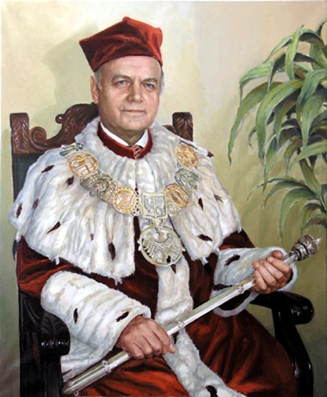

The Scientific Freedom Competition by

Prof. dr hab. Tadeusz Szulc

dr h.c. multi

for Young Researchers

Contact details:
Full name:
Degrees/professional title
E-mail:
Phone number:
Organization:
Address: | Country |  | City
 | Street |  | Post code

- Publication Requirements
Title
Corresponding Author's email
Co-Authors Names

The application and a project summary form must be sent in English to: congress.ecaas@gmail.com by February, 20th.

- Editorial requirements: Times New Roman font, title 12 pp bold, authors and affiliations 10 pp, text 11 pp, 1.15-line spacing, numerical citations – for example IEEE/Multidisciplinary Digital Publishing Institute citation style: [1]
- Structural abstracts: title, authors and affiliation, key words, introduction, materials and methods, results, conclusion (The maximum size of abstracts is limited to 250 words)
- Accepted file types: PDF, doc, docx
- WE ONLY ACCEPT TEXTS IN ENGLISH.

Place for the abstract:

